OUTPUT:

1. When phase angle, frequency and amplitude of shm are constants

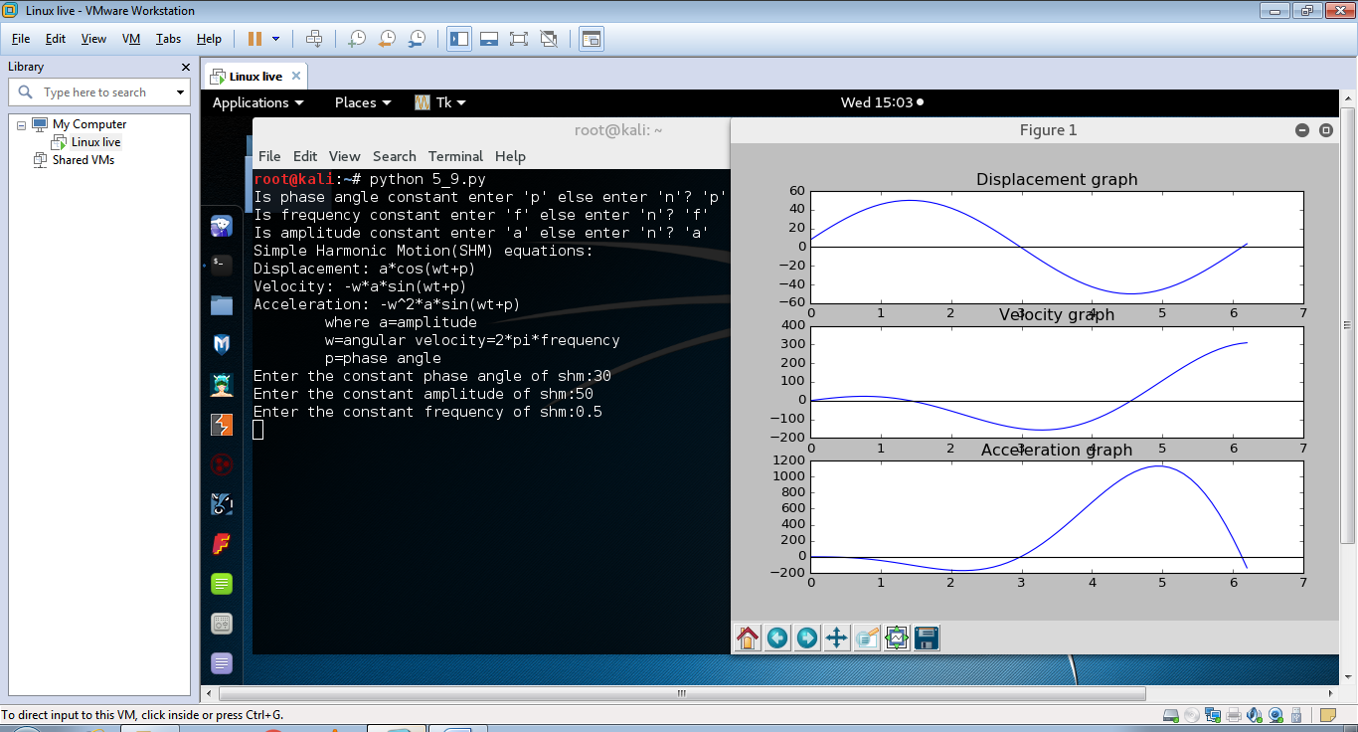

1. When phase angle and frequency are constants, amplitude of shm is different

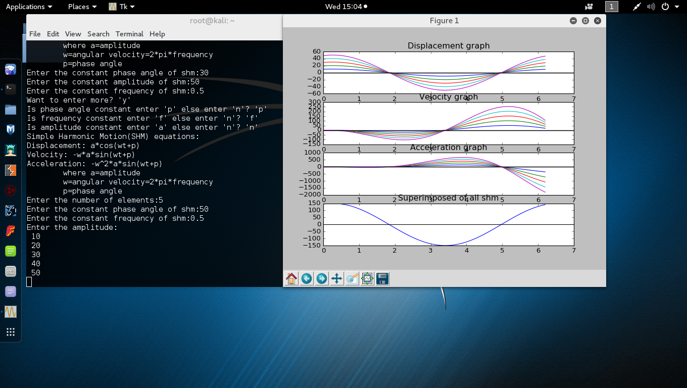

1. When phase angle and amplitude are constants, frequency of shm is different

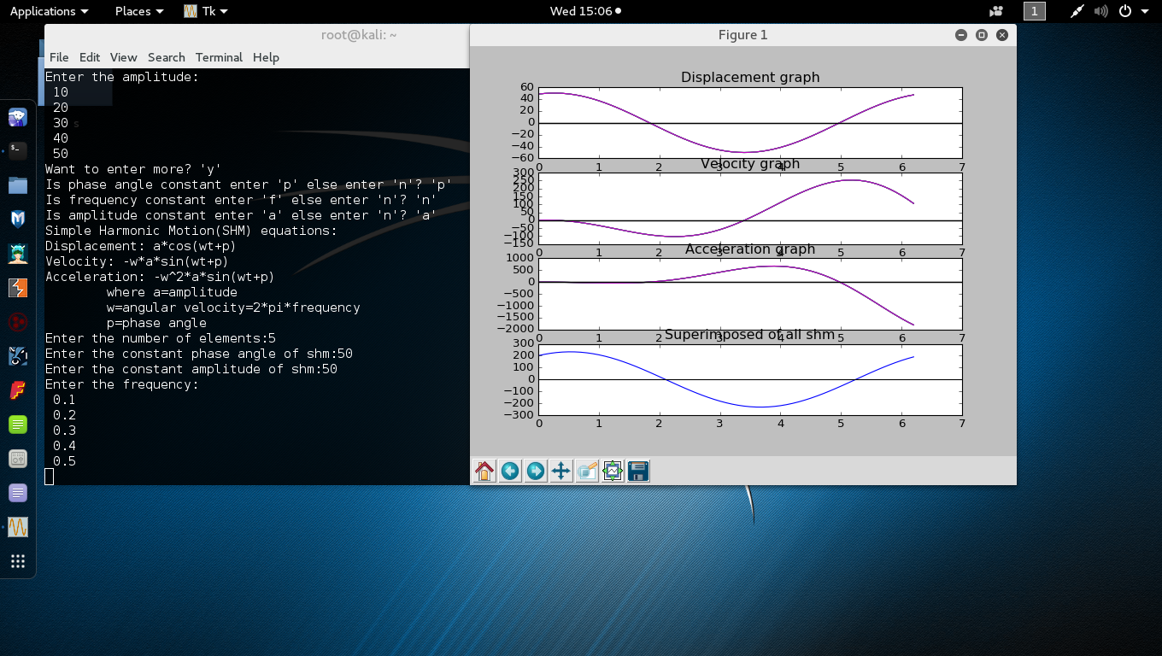

1. When phase angle is constant, amplitude and frequency of shm are different

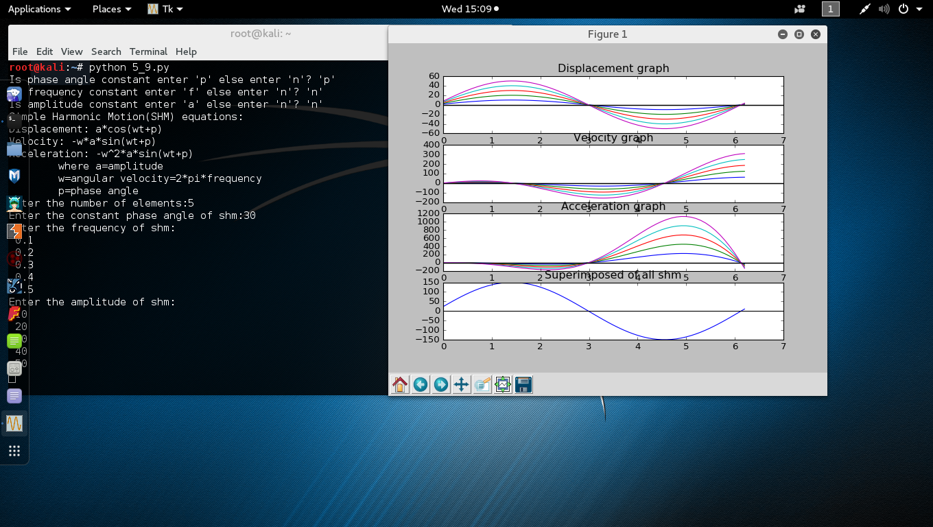

1. When amplitude and frequency are constants, phase angle of shm is different

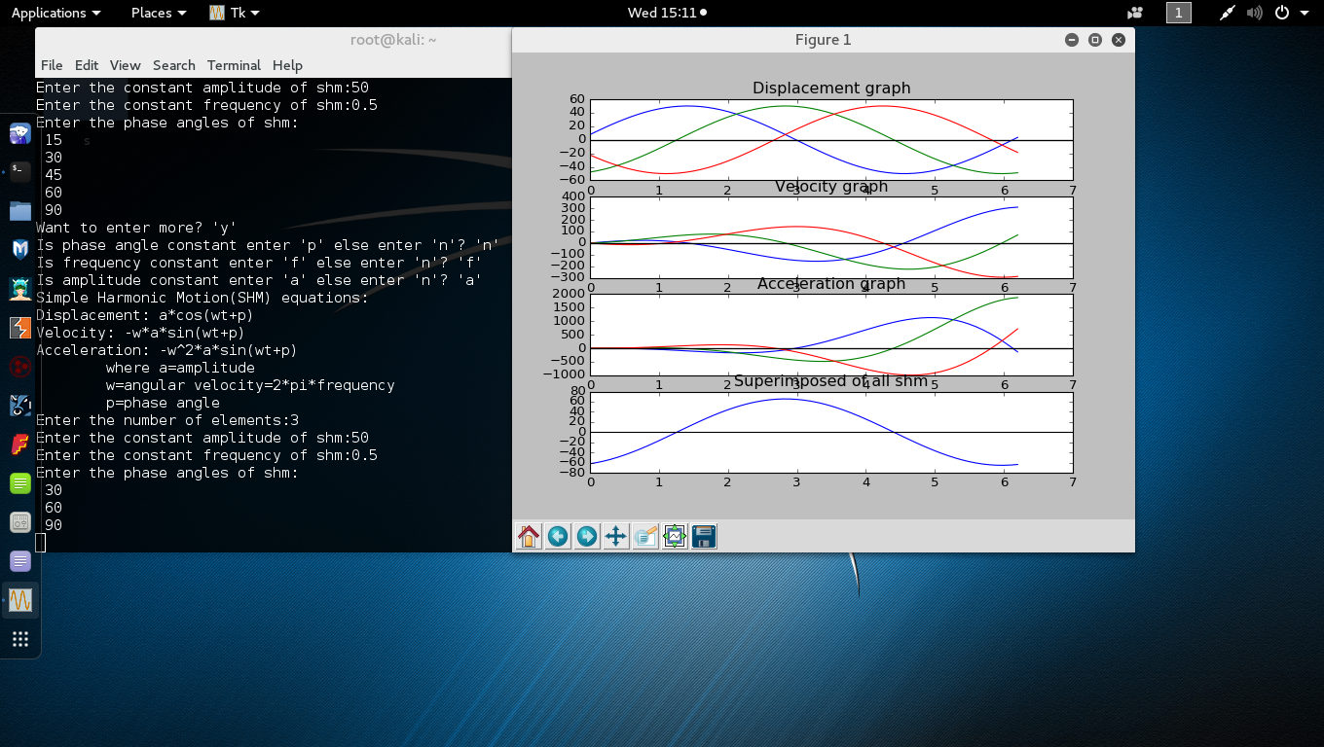

1. When phase angle and amplitude are constants, frequency of shm is different

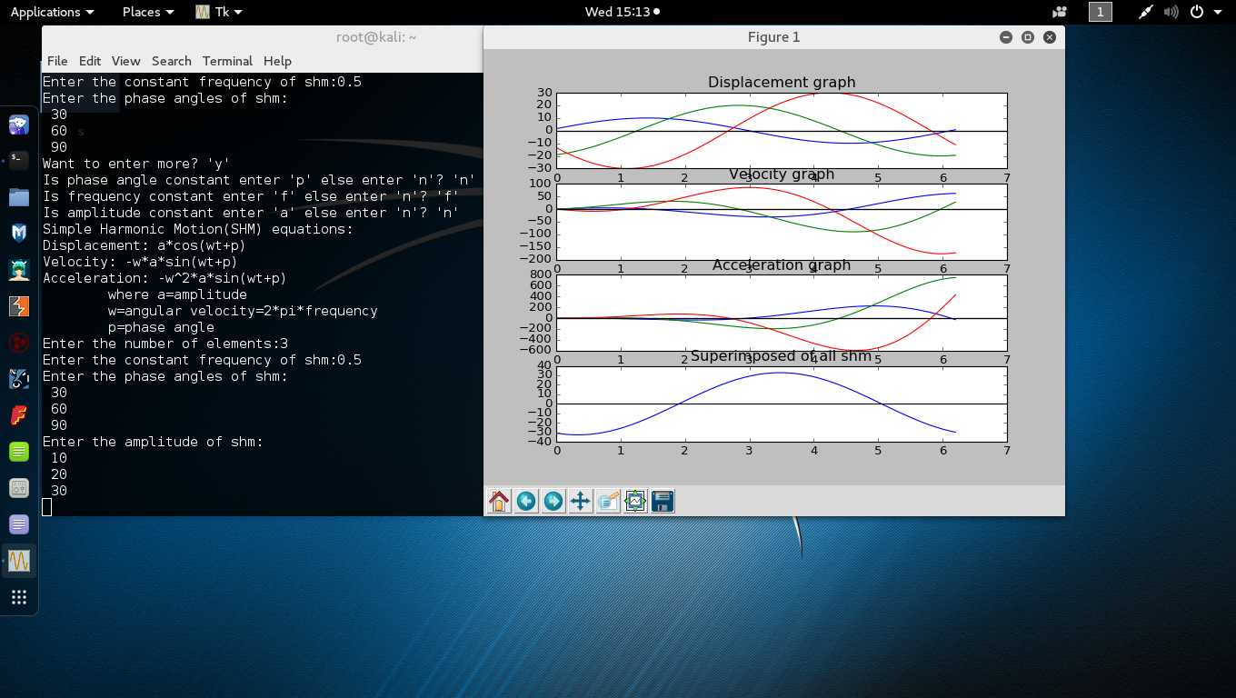

1. When amplitude is constant, phase angle and frequency of shm are different

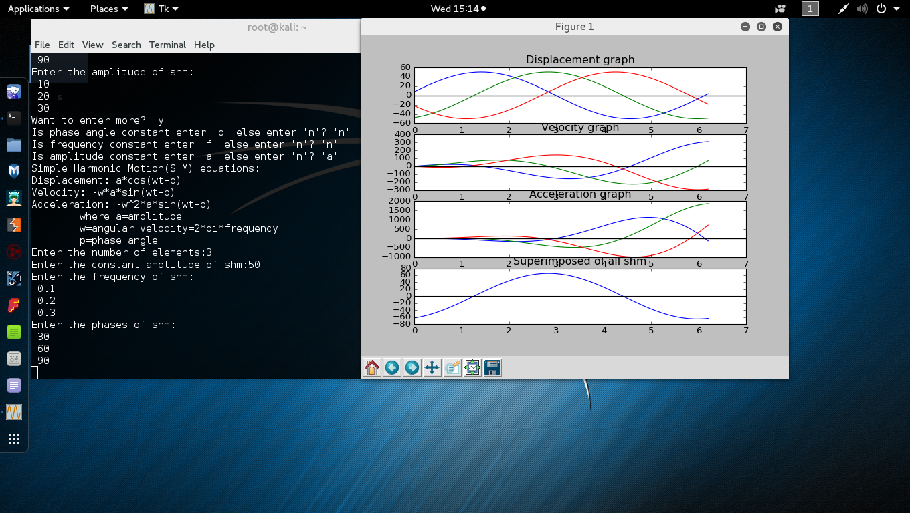

1. When phase angle, frequency and amplitude of shm are different